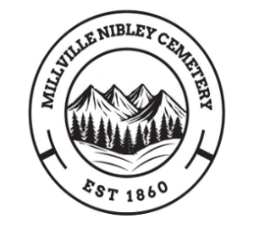

Millville-Nibley Cemetery Maintenance District
MillvilleNibleyCemetery@gmail.com
MillvilleNibleyCemetery.org

Public Hearing AGENDA

December 10, 2025 7:00 PM

Nibley City Offices
455 W 3200 S
Nibley, UT 84321

Virtual Meeting Link:
Topic: Millville-Nibley Cemetery Zoom Meeting
Time: Dec 10, 2025 07:00 PM Mountain Time (US and Canada)
Join Zoom Meeting
https://us05web.zoom.us/j/83781018016?pwd=28SIKYF3HtkW754WLSUqZZ8ueuiKBk.1

Meeting agenda
https://docs.zoom.us/agenda/doc/d45c3f29-d643-4371-aba6-4482478541df

Meeting ID: 837 8101 8016
Passcode: 4L1ZiG

Present Members: Jim Jenson, Dan Ames, Doug Pehrson, Jared Nichols & Kyle Anderson
Attending: Mary Jo Davis, Secretary & Emma Preston, Contract Treasurer
People in attendance:
Online participants:

Jim called the meeting to order

This meeting is for the sole purpose of discussing tax increase

1-The Millville-Nibley Cemetery Maintenance District has proposed an increase in property taxes.

2- The proposed increase in property taxes would provide the Millville-Nibley Cemetery with an additional $20,000 in revenue per year. The cemetery tax rate has not increased since 2010.

3- The proposed revenue will be used for opening a new section of cemetery. This includes installing new roads, plot markers, water and associated labor costs.

The following year, water conservation will be addressed through efficient irrigation methods.

4- The proposed increase is a 39.84% increase. This increase will amount to approximately $5-6 on a residence, and $9-10 on a business.

5-Public comments:

Motion to adjourn by , seconded by .

_______________________ ________________________
Jim Jenson, President Dan Ames, Board member

_______________________ ________________________
Jared Nichols, Board member Doug Pehrson, Board member

________________________ ________________________
Kyle Anderson, Board member Mary Jo Davis, Secretary

